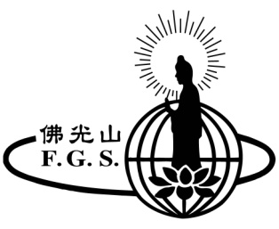
2022佛光山三佛中心大悲懺法會通啟
Great Compassion Repentance Service

為使觀音法門普利有情，本道場特於觀音聖誕、出家及成道紀念啟建大悲懺法會；祈願以此禮懺功德，回向眾等
福慧增長，平安吉祥。
In celebrating Guan Yin Bodhisattva’s birthday, ordination and enlightenment, Fo Guang Buddhist Temple, Boston will conduct Great Compassion Repentance Service 3 times a year. By participating in the ceremony, we benefit from the strength of the compassionate vows of Guan Yin Bodhisattva to find peace within ourselves and learn to treat others with respect and humility, bring harmony to our families and society.

日期Date：03/20, 07/17, 10/09 （星期日 Sunday）
時間Time: 9:30 am – 12:30 pm

年度懺主 $180 / 單次 $60 Annual Sponsor: $180 Single Sponsor: $60
供花果/供齋 （隨喜） Flowers and Fruits Offering: Open Donation
PAYPAL LINK ：https://www.fgsbtboston.org/donation-great-compassion-repentance/

支票抬頭請寫Please make check payable to FGBT and mail to
711 Concord Ave., Cambridge, MA 02138
Tel: (617) 547-6670 Email: boston@ibps.org

-----------------------------------------------------------------------------
大悲懺法會功德登記表
Great Compassion Repentance Service Registration Form
聯絡人 Contact person  (Eng.英) (Chinese 中) |  | 電話Phone：
 |  | E-Mail:
住址Address
懺主芳名Name | 類 別Type |  | 金 額 Amount
單次 Single Sponsor
年度懺主Annual Sponsor
單次 Single Sponsor
年度懺主Annual Sponsor
單次 Single Sponsor
年度懺主Annual Sponsor
供花果Flowers & Fruits | 供齋Food Offering

功德款: 現金/支票#: 三聯單號碼: 退稅單: 經辦人:

